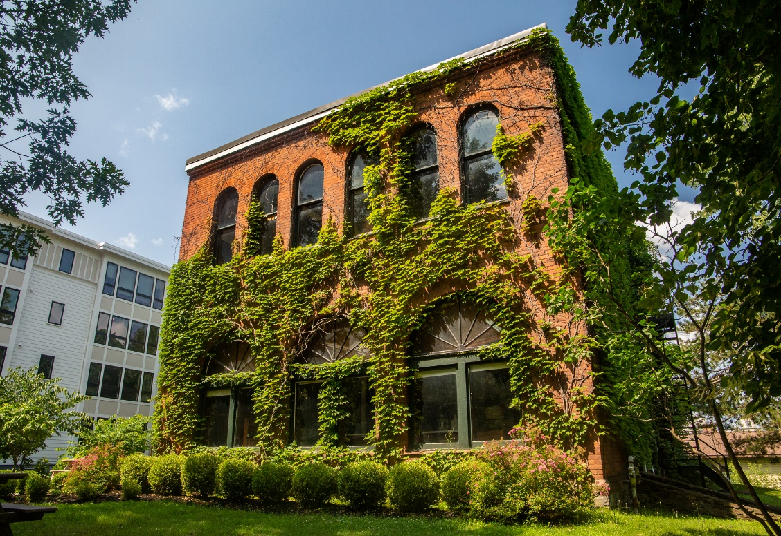

MINIMUM CAPACITY :-
The Minumum intake capacity
of students is between 3000-4020
children

LIBRARY :-
The Libarary is Available.

CANTEEN:-
The Canteen Facility is Available.

BOARDING :-
No availablility of boarding.

SPORTS :-
There are different categories
sports available.
Girls Volleyball
Boys Volleyball
Football

CASCADILLA SCHOOL
ITHACA - SCHOOL

School Detail :-
Cascadilla School is a co-ed preparatory school, in Ithaca, New York, established in 1876 as a tutoring and college preparatory school for Cornell University. Cascadilla School is a co-ed preparatory school, in Ithaca, New York, established in 1876 as a tutoring and college preparatory school for Cornell University. Cascadilla School is a co-ed preparatory school, in Ithaca, New York, established in 1876 as a tutoring and college preparatory school for Cornell University. Cascadilla School is a co-ed preparatory school, in Ithaca, New York, established in 1876 as a tutoring and college preparatory school for Cornell University.

